**Task No. 1:** Create Reusable Code/Software for generating Marksheet of a

student.

(Hint: Use Project 1 for calculation and Grading purpose)

**Solution:**

**Class Grading System**

using System;

using System.Collections.Generic;

using System.Linq;

using System.Text;

using System.Threading.Tasks;

namespace LAB11

{

class GradingSystem

{

string fname, lname, clases, year;

int age;

double total = 0, per;

string div;

public GradingSystem(string fname, string lname, string clases, string year, int age)

{

this.fname = fname;

this.lname = lname;

this.clases = clases;

this.year = year;

this.age = age;

}

public void calculate_percen()

{

Console.WriteLine("Enter Number Of Subjects : ");

int n = int.Parse(Console.ReadLine());

for (int i = 1; i <= n; i++)

{

int marks;

Console.WriteLine("Enter Marks Of Subjects : ");

marks = int.Parse(Console.ReadLine());

total += marks;

}

per = total / n;

if (per >= 60)

div = "First";

else

if (per < 60 && per >= 48)

div = "Second";

else

if (per < 48 && per >= 36)

div = "Pass";

else

div = "YOu are Pass but not . Do more efforts to clear this round :-)";

}

public void display()

{

// GradingSystem g11 = new GradingSystem();

Console.WriteLine("\t\t\t-------------------- Marksheet-------------------- \t\t\t");

Console.WriteLine();

Console.Write(" FirstName is {0}\n", fname);

Console.Write(" LastName is {0}\n", lname);

Console.Write(" Class is {0}\n", clases);

Console.Write(" Year is {0}\n", year);

Console.Write(" AGe is {0}\n", age);

Console.WriteLine();

Console.Write("Total Marks = {0}\nPercentage = {1}\nDivision = {2}\n", total, per, div);

}

}

}

**Main Method**

using System;

using System.Collections.Generic;

using System.Linq;

using System.Text;

using System.Threading.Tasks;

namespace LAB11

{

class Program

{

static void Main(string[] args)

{

Console.WriteLine("---------------------------------");

Console.WriteLine("Your First Name : ");

string fname = Console.ReadLine();

Console.WriteLine("Your LastName : ");

string lname = Console.ReadLine();

Console.WriteLine("Your class : ");

string clases = Console.ReadLine();

Console.WriteLine("Your year : ");

string year = Console.ReadLine();

Console.WriteLine("Your age : ");

int age = int.Parse(Console.ReadLine());

GradingSystem obj = new GradingSystem(fname, lname, clases, year, age);

obj.calculate_percen();

obj.display();

Console.WriteLine("---------------------------------");

}

}

}

**Output:**

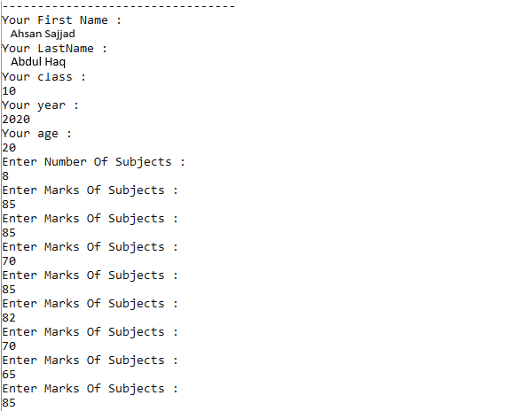

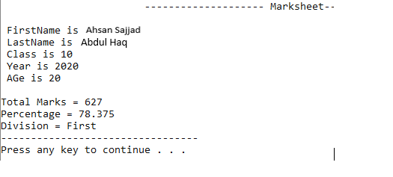

**Task No. 2:** Consume Google Maps Api in Html Webpage.

**Solution:**

**Script File**

<script>

<script src="https://maps.googleapis.com/maps/api/js?key="></script>

function initMap() {

var mapOptions = {

center: { lat: 3.456, lng: 5.46 },

zoom: 8.6

};

var map = new google.maps.Map(document.getElementById('map'), mapOptions); }

</script>

**HTML File**

<div id="map"></div>

**Output:**

